EXPERIMENT- 5
Q] Write a python program for Missionaries and Cannibals problem.
Aim-
To solve the Missionaries and Cannibals Problem using the Breadth First Search (BFS) algorithm and find a safe sequence of moves to transport all missionaries and cannibals across the river.
Algorithm-
- Represent each state as (Missionaries Left, Cannibals Left, Boat Side).
- Start from the initial state (3,3,1) where the boat is on the left side.
- Define the goal state (0,0,0) where everyone has crossed the river.
- Generate all possible valid boat moves:
- (2 Missionaries)
- (2 Cannibals)
- (1 Missionary)
- (1 Cannibal)
- (1 Missionary, 1 Cannibal)
- Check whether each new state is valid:
Missionaries should never be outnumbered by cannibals on either bank (unless there are no missionaries on that bank).
- Use BFS to explore valid states.
- Stop when the goal state is reached.
- Display the sequence of states.
Program-
from collections import deque
def is_valid(m, c):
if m < 0 or c < 0 or m > 3 or c > 3:
return False
if m > 0 and m < c:
return False
mr = 3 - m
cr = 3 - c
if mr > 0 and mr < cr:
return False
return True
def bfs():
start = (3, 3, 1)
goal = (0, 0, 0)
moves = [ (2, 0), (0, 2), (1, 0), (0, 1), (1, 1) ]
queue = deque()
queue.append((start, [start]))
visited = set()
while queue:
state, path = queue.popleft()
if state == goal:
print("Solution Found!\n")
for step in path:
print(step)
return
if state in visited:
continue
visited.add(state)
m, c, boat = state
for dm, dc in moves:
if boat == 1:
new_state = (m - dm, c - dc, 0)
else:
new_state = (m + dm, c + dc, 1)
if is_valid(new_state[0], new_state[1]):
if new_state not in visited:
queue.append((new_state, path + [new_state]))
print("No Solution Exists")
bfs()
Sample Input-
Missionaries = 3
Cannibals = 3
Boat Capacity = 2
Sample Output-
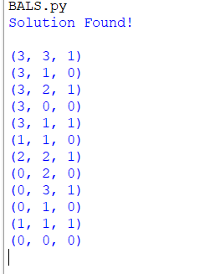

Result-
The Missionaries and Cannibals Problem was solved successfully using the Breadth First Search (BFS) algorithm, and all missionaries and cannibals were transported safely across the river without violating the problem constraints.

